I-Active Business Solutions

PLUG & PLAY DEDICATED OFFICES

CORPORATE PROFILE & BUSINESS OFFERING

INTRODUCTION

I-active Office Space

N ovel Office Space

Established in 1998 and acquired by Novel Group in 2006, Novel Office

Space is in the business of offering managed and serviced offices to

varied kinds of client requirements. We offer solutions suitable for all

ranges of clients’ right from very small clients up to medium sized

client up to large enterprise clients. Our offering is aimed at enabling

clients to focus their energies on managing their business and leaving

the management of the office infrastructure to us. Our offerings

include,

 Managed Offices

 Dedicated Offices

 Business Centers

 Recruitment Infrastructure

 Training Infrastructure

Novel Office Space has been servicing many clients since its

establishment and has developed an excellent brand name in the

market.

Managed Office Benefits

Managed Offices reduces the burden of setting up and maintain Office

Infrastructure and also has the following benefits,

 Helps avoiding capital expenditure with fixed operating lease

payments resulting in better cash flow with tax benefits.

 Helps focusing on core business activities as complete Office

management is taken care by Novel Office Space.

 Helps in managing office Infrastructure Cost as there is flexibility

of increasing or decreasing office space at will.

 Helps in reducing office management cost as NBC’s offers much

lesser cost due to its core strength in the same.

Benefits are lot more. Experience it to realize all the benefits.

WE OFFER OFFICES SPACES IN PRIME LOCATIONS IN BANGALORE

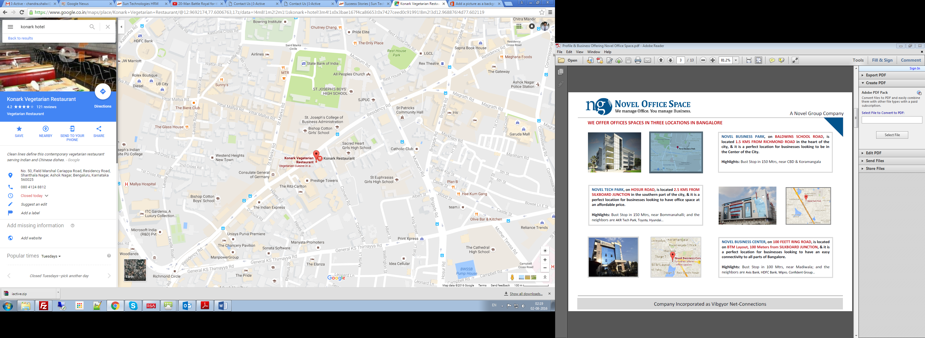

NOVEL TECH PARK, on HOSUR ROAD, is located 2.5 KMS FROM

SILKBOARD JUNCTION in the southern part of the city, & it is a

perfect location for businesses looking to have office space at

an affordable price.

Highlights: Bust Stop in 150 Mtrs, near Bommanahalli; and the

neighbors are AKR Tech Park, Toyota, Hyundai…



NOVEL BUSINESS CENTER, on 100 FEETT RING ROAD, is located

on BTM Layout, 100 Meters from SILKBOARD JUNCTION, & it is

a perfect location for businesses looking to have an easy

connectivity to all parts of Bangalore.

Highlights: Bust Stop in 100 Mtrs, near Madiwala; and the

neighbors are Axis Bank, HDFC Bank, Wipro, Confident Group…

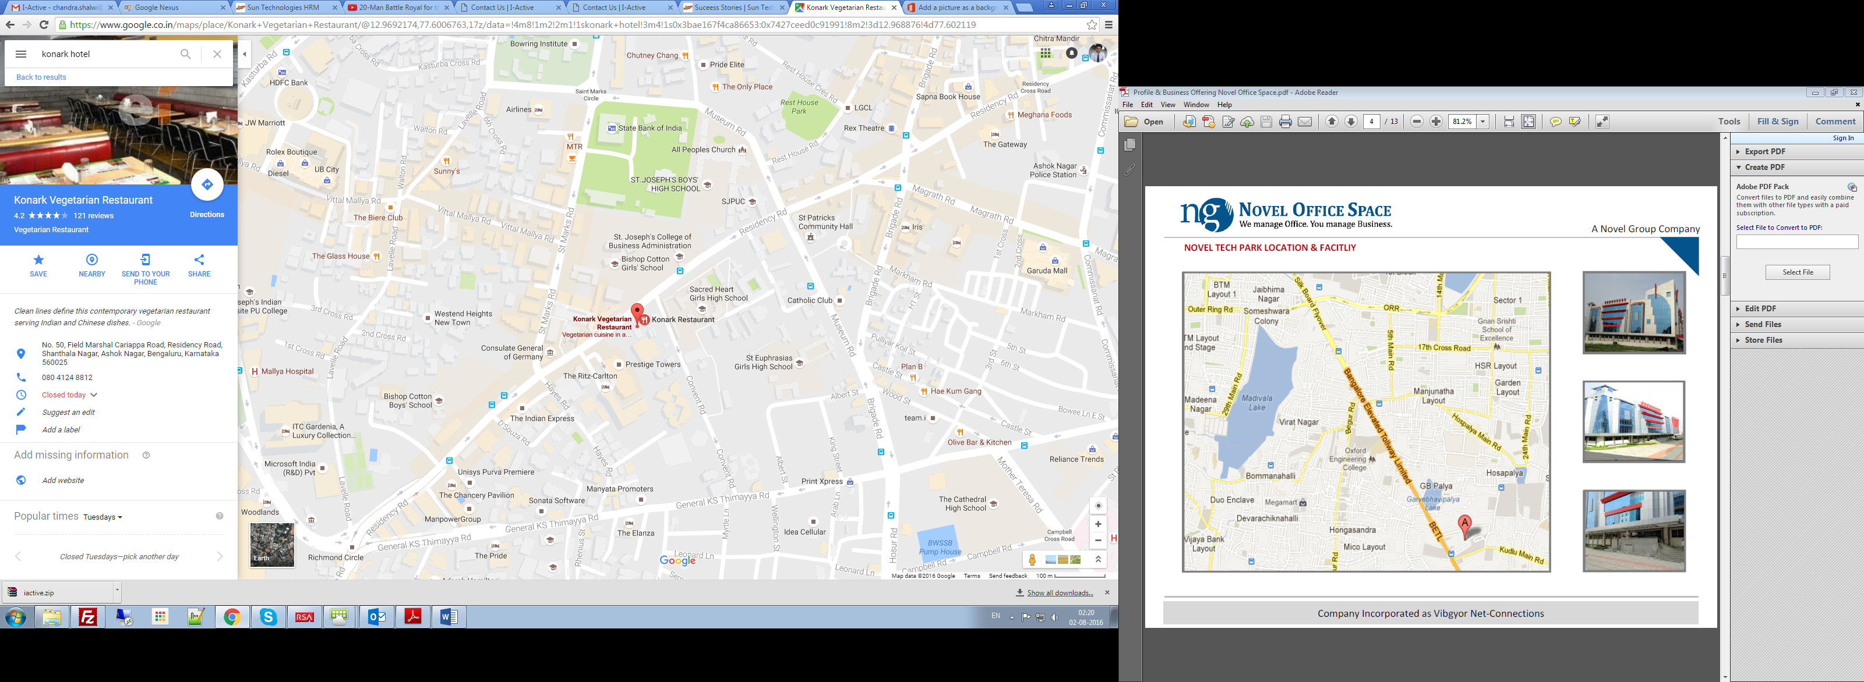

FACILITY INFORMATION

Details

 Location: GB Palya, Off Hosur Road, Bangalore

 Landmarks: Behind Hyundai Show Room

 Nearest Junction: Silk Board Junction (3 KMS)

 City Bus Stop: 200 Meters (Hosur Main Road)

 Total Area: 2,10,000 Square Feet (Approx)

 Floors: G + 4 Floors

 Plate Size: 42,000 Square Feet (Approx)

 Available Area: 500 Sq. Ft. to 50,000 Sq. Ft.

 Current Clients: AXA Group & R-Logic

 Neighbors: AKR Tech Park, Toyota, Hyundai

 Available Power: 1200 KVA

 Generator: 1700 KVA (1200 + 500)

 Car Park Ratio: 1:1000

 Flooring: Vitrified Tiles

 Toilets: Completed

 Lifts: 3 Passenger Lifts + 1 Service Lift

 Fire Exits: 2 Nos (Excluding Main Entrance)

 Ground to Ceiling Height: 3.2 Meters

MANAGED OFFICE SPACE

Customer Options

Novel Group offers Managed Offices with various options to

customers depending on their needs,

 Managed Office: Plug & Play Serviced Office on Opex model

with zero capital expenditure

 DR Center: BCP/DR Facility during non-operation of regular

facility due to disaster or any other reasons

 Plug & Play: Complete infrastructure for all types of IT/ITES

corporate firms

 Training Infrastructure: Complete Infrastructure for all types

of Training Requirement

 Seasonal Infra: Complete Infra for Seasonal Requirements on

per day, week or month basis

Value Additions

Novel Group offers Managed Offices services to customers along

with many value added services,

 Financial & Space Budgeting: Novel Business Center helps

customers in budgeting for their office space.

 Facility Identification: Novel Business Center helps in Facility

identification absorbing costs like Realtor Commission.

 Infrastructure Design: Novel Business Center designs the

entire infrastructure as per the Customer requirements.

 Licensing & Permissions: Novel Business Center helps in

obtaining the necessary licenses and Permissions.

 Compliances: Novel Business Center helps in registering for

Sales Tax, Company Registration, Service Tax, etc.

Business Offerings

Novel offers Managed Offices services to customers with many

facilities and services which include,

 Office Space: Workstations, Cabins, Meeting Rooms,

Conference Rooms, Training Rooms, Reception, Pantry, etc.

 Facilities: Electricity, UPS, Generator, Lighting, AC, CCTV,

Access Control, Fire Sprinklers, Smoke Detectors, etc.

 IT Infrastructure: Desktops, Laptops, Servers, Dialer/ACD,

Network, Storage, Printers, Internet, etc.

 Maintenance: Security, Housekeeping, Building Maintenance,

AMCs for equipment, Utilities, etc.

 Services: Recruitment, Payroll, Facility Management,

Administrative, activities, IT Management, etc.

Novel Offerings:

We can offer Fully Furnished, Serviced & Managed Dedicated Office for your needs at one of our facilities. The same will be a

DEDICATED OFFICE with the requisite no. of Linear Work Stations, Cabins, Meeting Rooms & Conference Rooms as per your

requirement and also you can take those as needed as Shared Resources. We will customize an offering for you as per your

needs

|  |  |
| --- | --- |
| Facilities Included in Our Offering for Work Areas | Additional Facilities at Nominal Cost |
|  AC, Electricity, UPS & Generator Backup   Passive Networking   Centralized EPABX   Call Handling & Mailbox Management   Common Cafeteria, Reception & Lobby   Drinking Water & General Maintenance   24/7 Access to Center, Dedicated Access Control& Access Card   Network & System Administration (if IT infra availed from Us) |  Meeting Room, Conference Room & Training Room   Computers, Servers & Other IT Hardware   Printer, Scanner, Photocopy, Fax   Dialer, CRM & Other Software Programs   Local, STD & ISD Calling Facility, PRI Lines etc.   Food & Beverages, Printing & Stationary   Payroll Services.   Administrative Services. |

Additional features that would be covered in the base offering:

 Common Area maintenance, Receptionist and Reception as a shared resource

 Electricity & DG Fuel costs, Shared cafeteria

 Security (24 hours) and House Keeping as a shared resource

Note:

 Car Park / Two Wheeler Park is charged extra over Seat Rental

Fully Furnished Details:

 External Partitions, Carpet/Vitrified Flooring, False ceilings

 AC, Lights, all electrical connection and fit outs.

 All Cat 6 based networking connection and Fit outs.

 Modular Workstations 4x2 Linear Workstation, 3x2 Linear Workstation or 5x4 Cubicles.

Commercials:

 Can be offered requirements are defined. We urge you to visit Novel Tech Park for a walk through at site.